Amazon Update Records - PII

Amazon Accounts:

UK1 account:

Site: https://sellercentral.amazon.co.uk/
Username: r.gutierrez@ecellglobal.com
Password: P@ssw0rd1

US account:
Site: https://sellercentral.amazon.com/
Username: r.gutierrez@ecellglobal.com
Password: P@ssw0rd1

UK2 account:
Site: https://sellercentral.amazon.co.uk/
Username: amazonsupport@ecellglobal.com
Password: rY$!D45O+@ilS51

JP account:
Site: https://sellercentral.amazon.co.jp/
Username: amazonsupport_jp@ecellglobal.com
Password: rY$!D45O+@ilS51

AU account:
Site: https://sellercentral.amazon.com.au/
Username: m.lozano+au@ecellglobal.com
Password: P@ssw0rd1

Note: Each account need OTP code

- A. Identify the SRN Amazon Account, you can check this on the page: http://34.196.137.61/barcode/AmazonImportOrdersUpdateRecords.php
- under Transaction ID

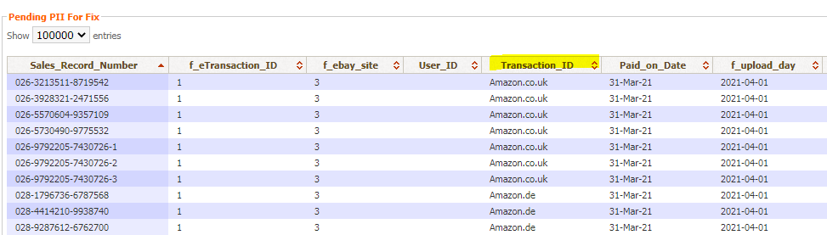

- Login to Amazon Account (accounts we’re given in page 1) .

- On the Menu, Select Orders > Order Reports
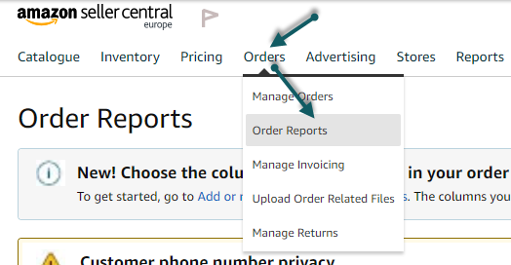

- Select New Orders Tab
  - Under Reports
  - Date Range: Last 7 Days
  - Click Request

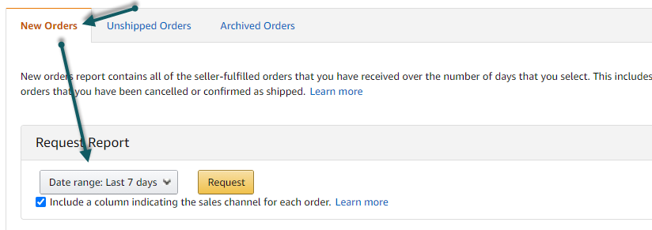

- Wait for the page to refresh for 5 seconds

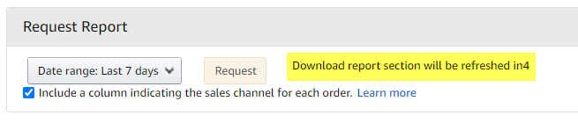

- Page will reload, then will show the report is in progress under Download Report.
  - Note on the Batch ID, then click Refresh button, until the Report Status changed to Ready and Download button is available
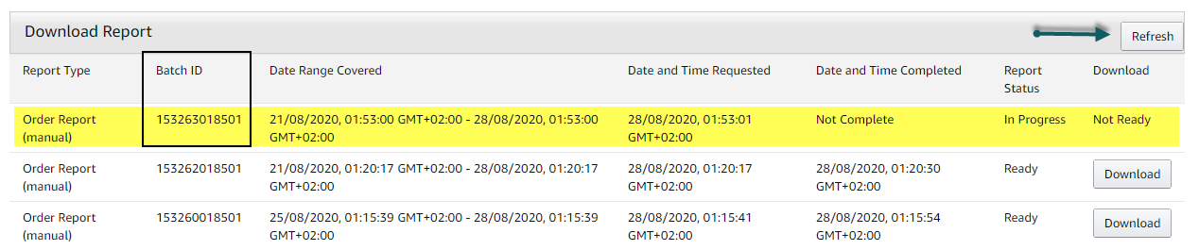

- Once ready click on the Download button to download the file
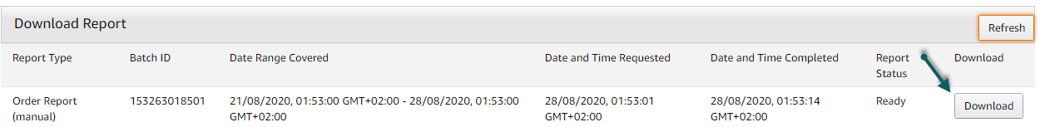

- Upload the downloaded file to this page: http://34.196.137.61/barcode/AmazonImportOrdersUpdateRecords.php

*** Follow Steps 2 – 8 until all accounts with error are downloaded/updated

